LEAS PARK JUNIOR SCHOOL: WHOLE SCHOOL ENGLISH OVERVIEW
 | Year 3 |  | Year 4 |  | Year 5 |  | Year 6
Autumn | Stories by the same author  I’ll Take You To Mrs Cole  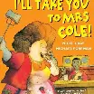  Poetry  Carnival, Carnival   | Instructions writing  Recipes  Recount/Narrative Film Unit  Coming Home  Information Text  Great Women Who Changed the World  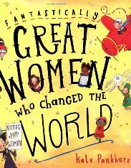  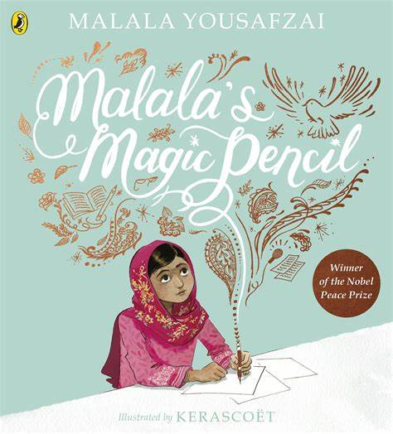 | Myths and Legends  King Arthur  -description  -narrative  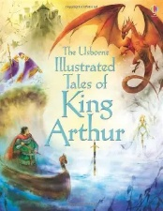  Iron Man  -description  Rainbow Bear  -description  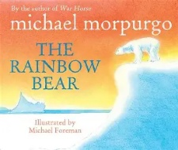  List Poetry  Anglo-Saxon kennings | Iron Man  -diary recount  -discussion  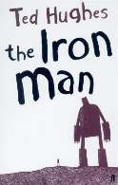  Rainbow Bear  -discussion  -non-chronological report  Explanations texts  Healthy diet, looking after your teeth. | Narrative writing:  Diary entries  Francis (Film Unit)  Boy in the Back of the Class  -Information texts  -argument and debate  -Newspaper reports   | Funny Poems  Revolting Rhymes- Roald Dahl  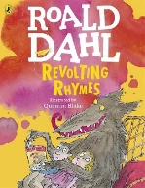  How Santa’s sleigh works (Hamilton resources)  -explanation text (BB) | Goodnight Mr Tom  -Character description  -Monologue  -Emotive recount  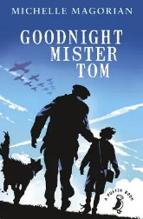  The Watertower  -suspense writing  WW2 poetry | Goodnight Mr Tom  -Formal persuasive letter  -Informal letter home  -Diary  The Watertower  -Newspaper report  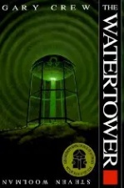
Spring | Myths and Legends  100 Literacy Lessons – Kuang LII  Fictional Recounts  Stone Age Boy (portal story)  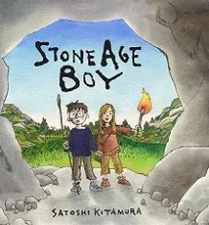 | Non-chronological reports  Stone age, bronze age, iron age: facts books.  Diary Entries / Letters  My Name is Not Refugee   | Fables  -Own fable (narrative)  How to Train Your Dragon  -character description  -narrative  Dragon Poems  Hamilton resources | Fable  -letter  -discussion  How to Train Your Dragon  -report  -persuasive speech  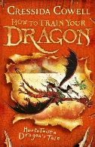 | Short stories  K Crossley-Holland  -mystery story (BB)  Macbeth William Shakespeare  -playscript  -Lady Macbeth diary entry (BB)  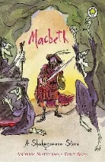 | Argument and Debate  Hamilton resources  Newspaper reports and journalistic writing  Tuesday by David Weisner  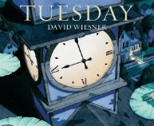 | Harry Potter and the Philosopher’s Stone; Goblet of Fire; Prisoner of Azkaban  - Howler  - Setting description  - 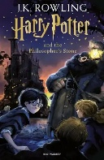  Topic based writing  -Diary  -Myth | Harry Potter and the Philosopher’s Stone; Goblet of Fire; Prisoner of Azkaban  -Newspaper report – reported speech  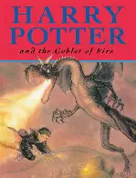  REVISION-  Topic based writing  - Non-Chron report  - Persuasive writing
Summer | Adventure Stories / Instructions  The Hodgeheg -Dick King Smith  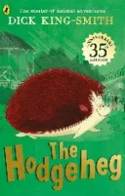  Shape Poetry  Hamilton unit  Plays and Dialogues  Traditional Tales | Recounts  The Journey- Aaron Becker  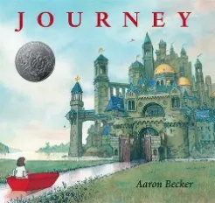  MLALP | The Man Who Walked Between the Towers  -emotive/tense narrative  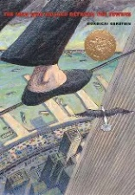  Nonsense Poems  Edward Lear  Stories from other cultures  Mufaro’s Beautiful Daughters/  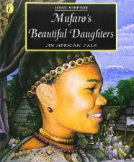 | Marcy and the Riddle of the Sphinx  -diary recount  -non-chronological report  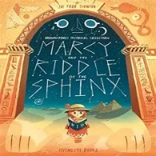  The Man Who Walked Between the Towers  -police report  Mufaro’s Beautiful Daughters  -formal letter  -informal letter  MLALP  -recount | Classic fiction  The Hobbit  -setting description  -Next chapter  -playscript conversation  -recount (BB)  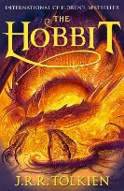  Fantasy Stories  Tales From Out of Suburbia by Shaun Tan  -Narrative  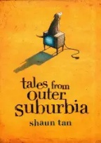  Performance poetry  What do you want to be? Wilf Mertton | Non-Chronological reports  Ancient Maya  Recounts  My Life at Leas Park | Kensuke’s Kingdom  -Setting  -Character description  Tin forest  -Compare setting descriptions  -Poetry  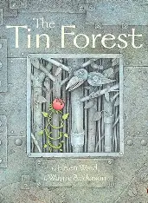 | Kensuke’s Kingdom  -Letter in a bottle  -Persuasive brochure  -Explanation (How to survive on the island  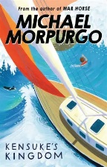  Tin Forest  -Persuasive argument  -Reports  -My life at Leas Park
 |  |  |  |  |  |  | SATS revision: various fiction, non-fiction and poetry texts.
*Updated July 2025

