Year 3
Books | 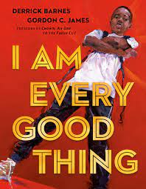 | 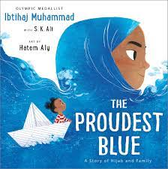 | 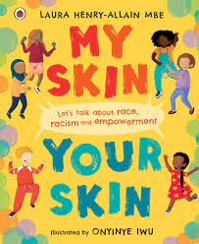
Books | I am Every Good Thing  Derek Barnes | The Proudest Blue  Ibtihaj Mohammed | My Skin, Your Skin  Laura Heny-Allain
Session objective and activity
Week 1 | To recognise individuality and personal qualities
Week 1 | Read ‘Every Good Thing’ – discuss the story and the author’s message/intentions.  Think about all the good things that you would describe about yourself.
Week 2 | To understand what is meant by identity
Week 2 | Discuss the story ‘The Proudest Blue’. Consider the religion of the main character and why religion can play an important part in some people’s identities.  Talk about differences between people that are visible and consider those which can’t be seen.  Make an identity jigsaw for yourself.
Week 3 | To understand what makes our skin the colour that it is
Week 3 | Look at scientific images of skin and discuss facts including how skin colour is genetic.  Learn about the words; race, racism and empowerment.  Make an ‘Anti-Racism’ poster including things that you have learnt.
Week 4 | To discover what it means to be anti-racist
Week 4 | Continue reading ‘My Skin, Your Skin’.  Focus on the line ‘we are not born racist’ – discuss what this means and why we think people become racist.  Consider what it means to be anti-racist and how we need to work together to dismantle racism.  Use skin-toned pieces of paper – find one to match own skin colour and to write ideas for making our school anti-racist.
Week 5 | To develop strategies to challenge racism
Week 5 | Recap what is race.  Consider what you would do if you experienced someone being racist.  Read poem ‘Be the change you want to see’ and consider what it is asking the reader to do.  Work with a partner to write a new poem about how to stand up to racism.
Week 6 | To recognise an example of where racism has happened.
Week 6 | Does racism happen today?  Look at the example of Marcus Rashford (taking the knee, the defacing of a mural and the racism of some football fans)
Week 7 | To know about personal identity and what contributes to who are
Week 7 | Compare similarities and differences with another person.  Create a leaflet about what makes you unique and special, your future ambitions and hopes and dreams.

Year 4
Books | 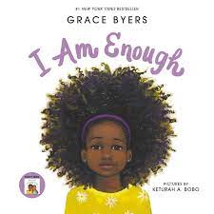 | 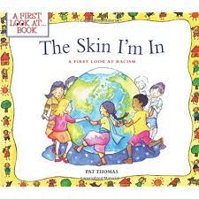 |  | 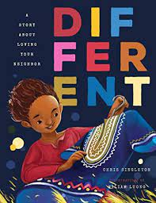
Books | I am Enough  Grace Byers | The Skin I’m in  Pat Thomas |  | Different  Chris Singleton
Books | 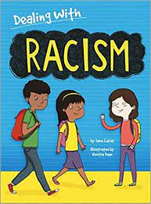 |  | 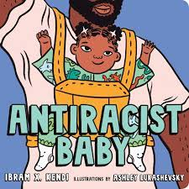
Books | Dealing with Racism  Jane Lacey |  | Anti-Racist Baby  Ibram X Kendi
Session objective and activity
Week 1 | To recognise the importance of self-respect and how this affects our thoughts and feelings about ourselves
Week 1 | Read ‘I am Enough’ and discuss themes and characters.  Discuss Maya Angelou quote ‘You alone are enough. You have nothing to prove to anybody.’ Link this to the story. Think of 6 reasons why ‘you are enough’ and share.
Week 2 | To recognise that everyone should expect to be treated with respect no matter the colour of their skin.
Week 2 | Discuss Nelson Mandela quote ‘No one is born hating another person because of the colour of his skin, or his background, or his religion. People must learn to hate, and if they can learn to hate, they can be taught to love, for love comes more naturally to the human heart than its opposite.’  Read ‘The Skin I’m in’ – discuss themes and feelings about racism and how you would respond if you witnessed this happening.
Week 3 | To know about diversity: what it means and the benefits of living in a diverse community.
Week 3 | ‘Why fit in when you were born to stand out?’ – discuss this quote.  Read ‘Different’ – discuss the story and its themes. Consider how someone would feel if they moved somewhere where they looked, sounded and dressed differently from everyone else.  Is it OK for someone to be treated unfairly because of the way the looked, sounded and dressed differently from others? How would you help someone if they moved to your school?  Learn what the word ‘diversity’ means and explain in your own words.
Week 4 | To know about strategies to respond to hurtful behaviour (experienced or witnessed)
Week 4 | Learn the definitions of the words; racism, prejudice, discrimination and consider examples of these.  Read ‘Dealing with Racism’ and discuss/answer questions.  Look at scenarios and consider what you think and would/could do in these situations.  Reflect on how you will spread the way racism is understood in school and how to help others understand that racism is not acceptable.
Week 5 | To create a charter showing anti-racist values
Week 5 | Recap previous learning and read ‘ Anti-racist Baby’. Brainstorm ideas about how to share the anti-racist message and create an agreed class charter.
Week 6 | To consolidate and reflect on learning
Week 6 | Discuss why football players take the knee.  Revisit and recall quotes and learning from the different books that have been read throughout the unit of learning.  Create a poster which shows learning and key messages.
Year 5
Books | 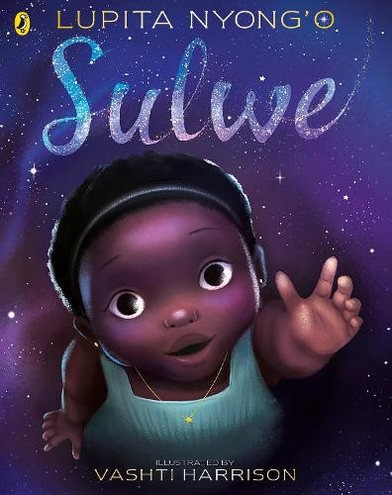 | 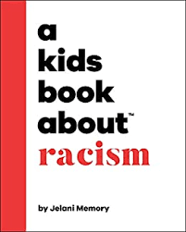 | 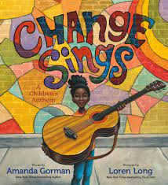 | 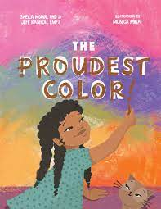
Books | Sulwe  Lupita Nyong’o | A Kids Book About Racism  Jelany Memory | Change Sings  Amanda Gorman | The Proudest Colour  Sheila Modir, Jeffrey Kashou, Modir
Session objective and activity
Week 1 | To know about respecting differences and similarities between people
Week 1 | Read ‘Sulwe’ – discuss and consider themes and messages.  Consider your own identity like Sulwe does. Children to reflect on what things have influenced their own identities, things that they have in common with others and the things that make them unique.
Week 2 | To know about racism and what it means
Week 2 | Discuss the quote ‘It is not our differences that divide us. It is our inability to recognise, accept and celebrate those differences.’ How does this quote relate to us?  Read ‘A kids book about racism’. Think about how people are different and how differences between people might divide them.  Plan a guide to teach younger children about racism; what it is, how it happens and how it makes people feel.
Week 3 | To know about stereotypes and how I can positively influence people’s behaviours and attitudes towards others.
Week 3 | Matching activity – which person does which job? Were your views impacted by stereotypes? Discuss what ‘stereotype’ means and how it links to our learning.  Read ‘The Proudest Colour’ – discuss themes and messages.  Watch BBC Bitesize clip – Not Racist vs anti-racist: what’s the difference?  Reflect on what it means to be anti-racist.
Week 4 | To know about strategies for challenging stereotypes
Week 4 | Read ‘The Proudest Colour’.  Why do we all have different skin colours? – Discuss and watch video clip explanation.  Reflect on what Zahra (character) learnt in the story and why this was important to her.  Explain that often we learn about the achievements of people in history and this is an opportunity to learn about people who make a difference to our world today e.g. Malala Yousafzai, Marcus Rashford The more we know about their achievements the more we can acknowledge and celebrate them.
Week 5 | To know about what living in a community means
Week 5 | Recap previous learning.  Discuss the US inauguration - (Joe Biden, Kamala Harris) and the significance of the role that Amanda Gorman played – watch clip ‘The Hills we Climb’.  Link Kamala Harris to ‘The Proudest Colour’ book.  Read ‘Change Sings’ and make links.  Consider what changes you would want to make in the world
Week 6 | To reflect on our learning
Week 6 | Revisit quotes and questions from previous learning and re-watch video clips  Read full version of ‘Change Sings’ – children/class to write their own version of this poem.

Year 6
Books | 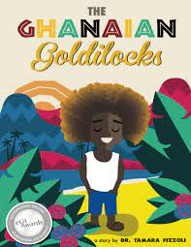 | 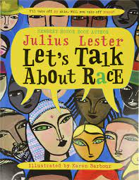 | 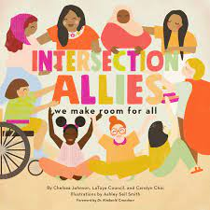
Books | The Ghanaian Goldilocks  Tamara Pizzoli and Phi Howell | Let’s Talk About Race  Julius Lester and Karen Barber | Intersection Allies – we make room for all  Chelsea Johnson, Latoya Council
Session objective and activity
Week 1 | To know about diversity and what it means
Week 1 | Look at the book cover – discuss where it is set. Read ‘Ghanaian Goldilocks’.  Answer questions and discuss how it is similar/different to other known stories.  Consider Kolifi’s hair and how this makes him stand out and unique. Relate to the term ‘diversity’.  Complete a culture wheel and reflect on all the things that make you unique. Compare with others.
Week 2 | To know about prejudice and how to recognise behaviours/actions which discriminate against others
Week 2 | Learn a little about the apartheid in South Africa. Look at ‘Whites Only’ sign images and discuss.  Discuss the concept that race is a social construct and consider the scientific reasons that humans are different.  Reflect on this learning and link to the culture wheels from the previous week.
Week 3 | To know about prejudice and actions which discriminate against others; ways of responding to it if witnessed or experienced.
Week 3 | Look at picture of twins with different skin colour and answer ‘why do we have different skin colours?’  Watch video clip about racism/Neal Maupay (footballer)  Discuss difference between being ‘non-racist’ and ‘anti-racist’ and how we can actively stand up to racism.  Explain the science of skin colour and answer questions around this.
Week 4 | To know about prejudice and how to recognise behaviours/actions which discriminate against others.
Week 4 | Revise what melanin is and how this affects skin colour and is genetic.  Discuss book Intersection Allies – what do you think it is about?  Make links with the book and the killing of George Floyd and the police response in the US.  Discuss protected characteristics and that it is illegal to discriminate because of these.  Children to choose protected characteristics that have significance for them and write about them making links to their previous learning.
Week 5 | To know about ways of responding to racism/prejudice if witnessed or experienced.
Week 5 | Discuss ‘empathy’ and why it is important.  Watch video ‘What is empathy?’ and discuss – link to examples of what racism looks/sounds like.  Look at data regarding racist incidents.  Consider what a ‘new normal’ (linked to quote by Barack Obama. Write own ideas for a set of rules for a ‘new normal’.
Week 6 | To summarise everything that has been learned about diversity, prejudice and discrimination.
Week 6 | Review learning from previous sessions and create selection of work that can be shared with others.  Create a set of rules/key messages regarding racism and how to be anti-racist.

